PHARMACOLOGY & THERAPEUTICS
PHARMACOKINETICS
Nancy A. Muma, Ph.D.

Volume of distribution (V_{d}):

V_{d} = amount of drug/concentration of drug in plasma

V_{d} = dose
C_{p}

AUC: the area under the plasma or blood-concentration:time curve.

Bioavailability: F = AUC (oral)
AUC (IV)

MEC: usually a minimum effective concentration (i.e., MTC minimum therapeutic concentration) of drug in the blood or plasma is needed for a therapeutic effect.

Clearance:

A. The rate of elimination of a drug by all routes relative to the concentration of the drug in a biological fluid (usually blood or plasma).

CL = rate of elimination / concentration_{plasma}

B. CL = KV_{d}
K = elimination rate constant

Elimination kinetics:

A. 1st order kinetics:

1. Half-life:

t2 = 0.693V_{d} / CL

CL = KV_{d} so t2 = 0.693
K

B. 0 order kinetics:

A constant amount of the drug is eliminated in a given period of time.
A half-life cannot be described.

Extraction ratio:

1. ER = (C_{i} - C_{o} / C_{i} )

ER= extraction ratio
C_{i} = concentration of drug in the blood entering an organ
C_{o} = concentration of drug in the blood exiting an organ

2. CL_{organ} = Q x ER
Q = blood flow

DOSAGE REGIMEN DESIGN

Single dose:
. Estimates can be made from the graph

a. Half-life estimated from the slope

b. Volume of distribution from extrapolation of second phase of curve back to y-intercept.
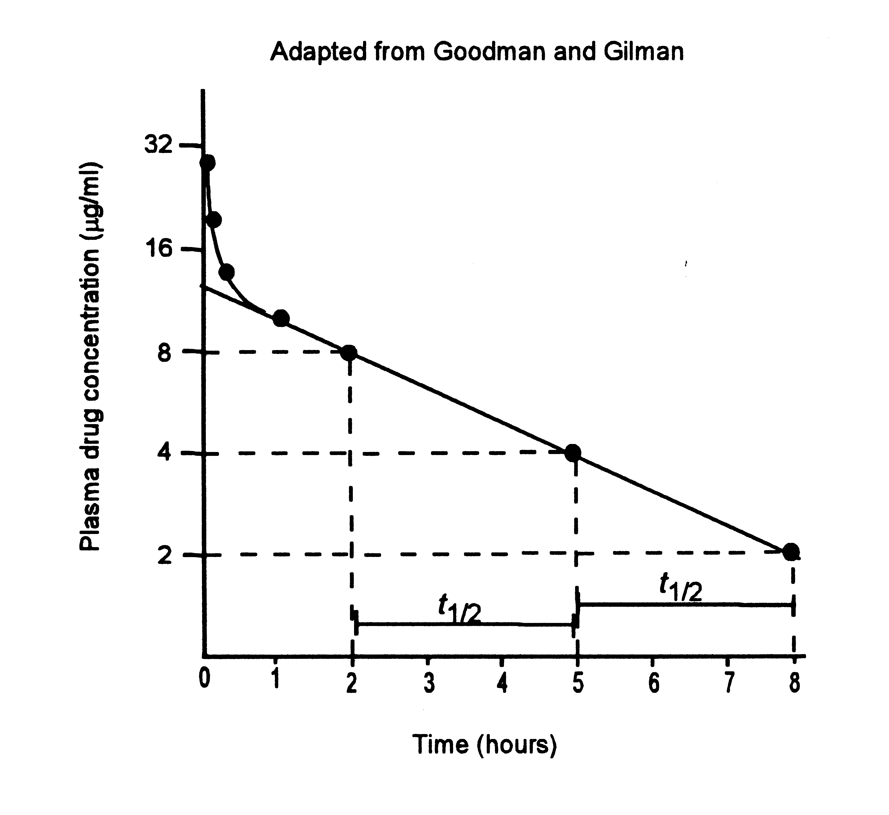

Multiple Doses:
A. Maintenance dose
1. For IV dose: dosing rate = CL_{p} x C_{p}

2. For multiple intermittent doses:

a. (F x Dose) / dosing interval = CL_{p} x C_{p}

b. Peak and trough drug concentrations.

Peak: C_{p, max} = (F x dose / V_{d} )) / fraction loss in a dosing interval

Trough: C_{p, min} = C_{p, max} x fraction remaining after dosing interval

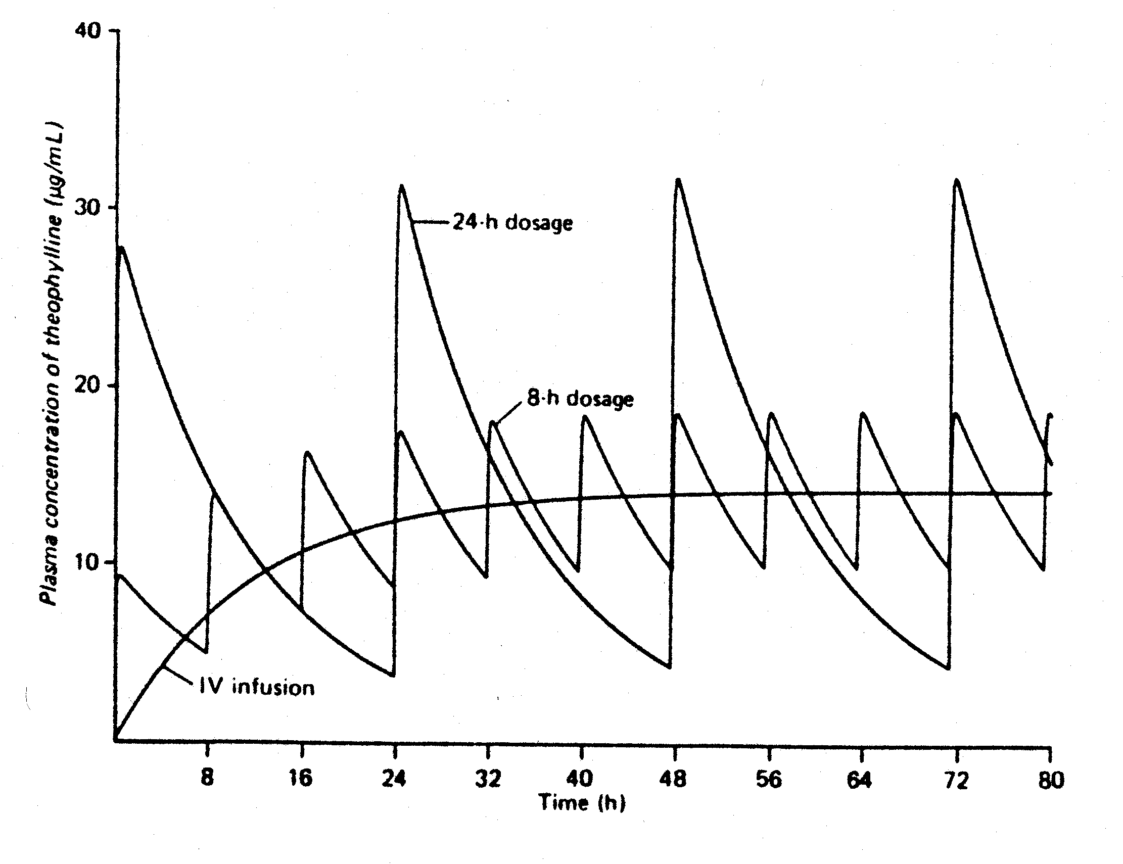

From: Katzung

Concentration kinetics:

log C = log C₀ -k (t)
2.3

-k = log C₁ - log C
2.3 t₁ - t₂

Plateau levels of a drug (given such that administration rate equals rate of elimination) are reach after four and one-half-lives (i.e., 4.5 x t2)

B. Loading dose

LD = V_{d} x C_{p}

Renal disease: D_{r} = (D) CL_{sr}
CL_{s}

T_{r} = (T) CL_{s}
CL_{sr}

creatinine clearance = 160 - age (years) x weight (kg)
(L/h) 22 x serum creatinine (mg/dL) 70

The predicted clearance in women is 90% of the value calculated above.

